EQUILIBRIUM PROBLEMS
AAIMS Fall 2022 WORKSHOP

1. A flask containing 1.00 atm of NO2 and 1.50 atm of N2O4 is allowed to proceed to equilibrium at a given temperature.
2NO2(g) N2O4(g)

When equilibrium is established the partial pressure of NO2 is 0.500 atm.

- Calculate the magnitude of the equilibrium constant for this reaction at this temperature.

b) After the reaction mixture has established equilibrium, 0.250 atm of N2O4 are added to the reaction flask. Which direction (left to right; right to left; or no change) will the reaction proceed to re-establish equilibrium? Explain in terms of Q and K_{p}.

c) Does the position of equilibrium favor the products side or the reactants side? Explain.

2. The equilibrium constant for the reaction
2NO(g) + O2(g) 2NO2(g)

At a certain temperature is 1.48 x 104. The equilibrium constant for the reaction
NO2(g) $\frac{1}{2}$O2(g) + NO(g)
What is the equilibrium constant for this reaction at the same temperature?

3. In the graph below the endothermic reaction BR(g) B(g) + R(g) is represented. Initially only BR(g) is present in the reaction vessel. The marks along the x-axis are in 1-minute increments. The initial [BR] (y-axis) is 2.0 M. The reaction begins about 1.5 minutes in this case.
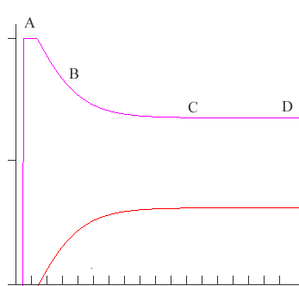

- At what point (indicate a letter) does the reaction attain equilibrium? NOTE: You can also label the graph if you prefer.

- Indicate whether K for the reaction is greater than 1, less than 1 or equal to1. Explain.

- At point ‘B’ indicate how Q compares to K. Explain.

- In this new view the same reaction has occurred. Indicate the stress (at point E) that was imposed on the system, and explain how the system changed as a response to the stress.

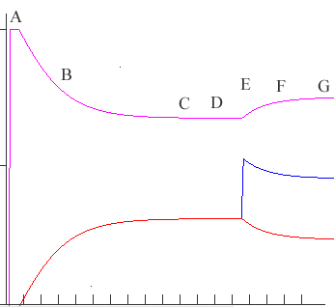 | Explain:

- In this new view the same reaction has occurred. Indicate the stress (at E) that was imposed on the system, and explain how the system changed as a response to the stress.
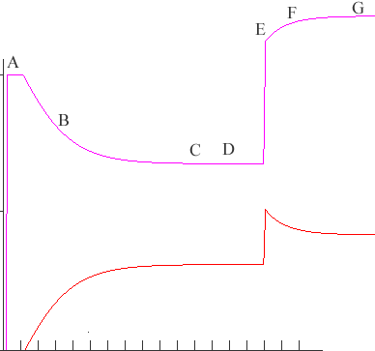 | Explain:

4. a) The following reversible reaction occurs at 25. ˚C.
2HOCl(g) H2O g) + Cl2O(g)

A reaction vessel that contains 0.500 atm of HOCl initially is allowed to attain equilibrium at 25 ˚C. Analysis indicates 0.0650 atm of HOCl are present at equilibrium. Calculate Kp for the reaction as written.

b) After the reaction in 4a attains equilibrium, some HOCl is added so the new partial pressure of HOCl is 0.200 atm. Calculate the new equilibrium amounts of the system when equilibrium is re-established.

5. In the reaction.

HNO3(aq) + KOH(aq) → KNO3(aq) + H2O(l)

- Write the net ionic equation and determine the value of K for the neutralization reaction between nitric acid and potassium hydroxide?

b) In the neutralization reaction between H2PO4–(aq) and HF(aq)

H2PO4–(aq) + HF(aq) → H3PO4(aq) + F –(aq)

i) Identify a conjugate acid-base pair in the equation above.

ii) Determine K for the reaction above. Show your work. (see table of K’s at the end of this document.)

iii) Which acid in the above reaction is the strongest? What evidence did you use to make the claim?

6. Phosphoric acid, H₃PO₄(aq) is a triprotic acid with the following equilibrium constants; K_{a1} = 7.3 x 10⁻³, K_{a2} = 6.2 x 10⁻⁸, and K_{a3} = 4.2 x 10⁻¹³.
a) Is a solution that is 0.1 M H₃PO₄(aq) acidic, basic or neutral? Explain.

b) Is a solution that is 0.1 M NaH₂PO₄(aq) acidic, basic or neutral? Explain.

c) Is a solution that is 0.1 M Na₂HPO₄(aq) acidic, basic or neutral? Explain.

d) Given that NaH₂PO₄ is soluble in water identify the two ions present when NaH₂PO₄ dissolves in water.

e) Of the two ions in the NaH₂PO₄ solution, identify the ion that can act as a Brønsted-Lowry base?

f) The weak acid, HC₂H₃O₂ (K_{a} = 1.8 x 10⁻⁵) is added to the solution of NaH₂PO₄.
- Write a Brønsted-Lowry acid-base balanced chemical equation between HC₂H₃O₂ and the ion in the solution that will behave as a base and label all species as acid, base, conjugate acid or conjugate base.

- The K for the above reaction has a value of 2.33 x 10-3. Do you agree or disagree? Support your claim with an explanation.

- Which of the two acids is the strongest?

7. In aqueous solution, trimethylamine, (CH3)3N, acts as a weak base. The pH of 0.250 M (CH3)3N is 11.60

- Write the balanced chemical equation that describes how (CH3)3N acts as a weak base.

- Write the equilibrium constant expression, Kb, for trimethylamine. (3)

- Calculate the value of the [OH–] in 0.250 M (CH3)3N.

- Calculate the value of Kb for the reaction.

Dimethylamine, (CH3)2NH is also a weak base. A 25.0 mL sample of 0.350 M (CH3)2NH is titrated with 0.500 M HCl. The value of Kb for (CH3)2NH is 5.4 x 10–4.
- Calculate the volume of 0.500 M HCl that must be added to reach the equivalence point of the titration.

- A student claims the [OH–] = Kb at the half-equivalence point of the titration. Provide evidence that supports the claim.

- The pH at the equivalence point of the titration is 5.59. Show the calculation that produces this pH.

- Which of the two bases, trimethylamine or dimethylamine is the stronger base? Explain.

8. Calculate the pH of each of the following,

a) 0.300 M HC₃H₅O₂ (propionic acid)

b) 0.400 M CH₃NH₃NO₃

c) 250. mLs of a solution that is 0.450 M CH₃NH₂ and 0.400 M CH₃NH₃NO₃.

d) after adding 0.0025 mol HNO₃ to the solution in part 2c.

9. A solution of NaOH with an approximate concentration of 0.1 M is to be standardized by titration. Assume that the following materials are available.

Clean, dry 25 mL buret  125 mL Erlenmeyer flask  Wash bottle filled with distilled water | Analytical balance  Phenolphthalein indicator solution  Potassium hydrogen phthalate, KHP (MM = 204 g mol-1), solid monoprotic acid (to be used as a primary standard)

- Briefly describe the steps you would take, using the materials listed above, to standardize the NaOH solution. Indicate the data you must collect, and how the data is used to calculate the concentration of the NaOH solution.

- After the NaOH is standardized (to 3 significant figures) it is used to titrate a weak monoprotic acid, HX. The equivalence point is reached after adding 15.0 mL of the NaOH solution. In the space below sketch a titration curve, showing the pH changes that occur as the volume of NaOH solution added increases from 0 to 25 mL. Clearly label the equivalence point on the curve.
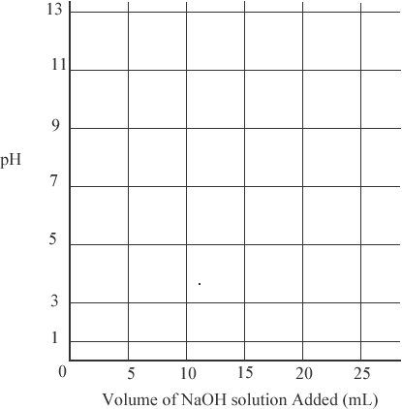

c) Describe how the value of the acid dissociation equilibrium constant, Ka, for the weak acid, HX, could be determined from the titration curve you drew in part b.

10. In aqueous solution, lactic acid, HC₃H₅O_{3,} behaves as a weak acid. In 0.0247 M HC₃H₅O₃ at 25 ˚C, the hydrogen ion concentration, [H+] is 1.79 x 10-3 M. In answering the following questions assume that the temperature is constant at 25 ˚C and that volumes are additive.
a) Write the weak acid dissociation chemical equation for lactic acid, HC₃H₅O₃.

- write the equilibrium-constant expression for the reaction in part a).

- Determine the pH of 0.0247 M HC₃H₅O₃(aq).

- Determine the value of the acid ionization constant, K_{a}, for HC₃H₅O₃(aq).

- In an experiment a 20.0 mL sample of 0.0247 M HC₃H₅O₃(aq) was placed in a flask and titrated to the equivalence point and beyond using 0.0450 M KOH.
- Determine the volume of 0.0450 M KOH that was added to reach the equivalence point.

- Is the pH of the mixture at the equivalence point, greater than, less than or equal to 7? Explain. (Do not do a calculation.)

11. The graph below shows the result of the titration of a sample of a 0.10 M solution of a weak acid, HA, with a strong base, 0.10 M NaOH.

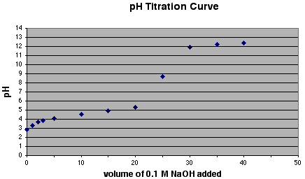

- What are two features of the graph above that identify the acid as a weak acid?

- without doing calculations, describe one method by which the acid ionization constant for the unknown substance can be determined.

- Using the graph above, sketch the titration curve the would be obtained if an equal amount of 0.10 M HCl were used instead of the 0.10 M HA

- If 0.20 M NaOH were used to titrate the same volume of the 0.10 M HA, what would be the volume of base added at the equivalence point? Would the pH at the equivalence point be equal to, greater than, or less than the pH at the equivalence point using 0.10 M NaOH? Explain.

MULTIPLE CHOICE:

1. The following diagram represents a reaction chamber
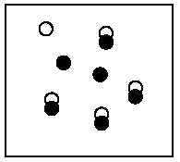
where the chemical reaction,
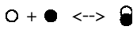
is at equilibrium

If nine units of
are added to the reaction chamber, which of the following best represents the system when it reestablishes equilibrium?
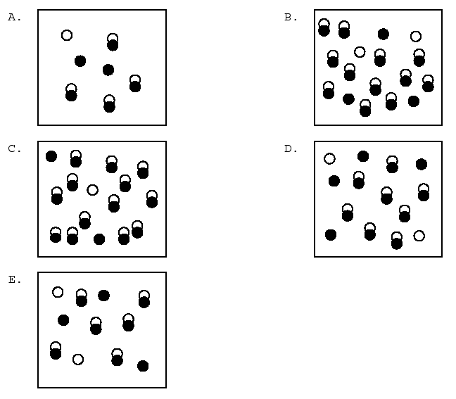

2. Consider the following hypothetical reaction:

A2(g) + 4B2(g) 2AB4(g)

Initially 3 molecules of A2 and 7 molecules of B2 are placed in a reaction vessel. After a period of time 2 molecules of AB4 are found in the vessel. Which of the following diagrams represents this final state?
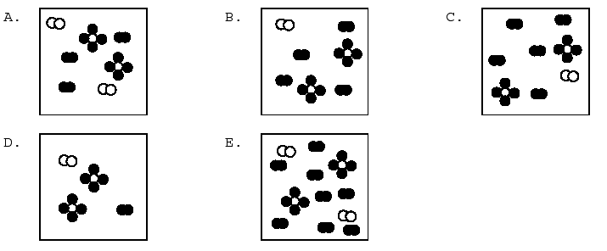

3. The following diagram represents a hypothetical chemical reaction
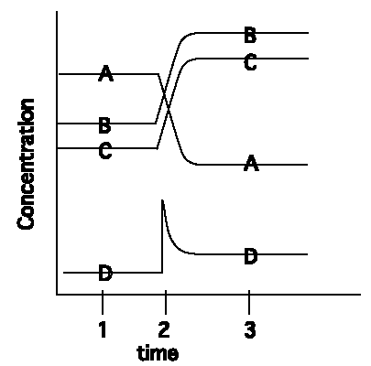
At time 2 a change takes place in the reaction. Which of the following statements about this chemical system is false?

A) At time 3 the system is at equilibrium.
B) At time 2 the concentration of D was increased
C) The change at time 2 caused more C to be formed.
D) The diagram is an illustration of the effect that changing the concentration has on a reaction at equilibrium
E) D and A are on opposite sides of the equation representing the reaction

Answer Questions 4 - 6 over the reaction
2H2(g) + S2(g) 2H2S(g) Kp = 4.2 x 102 at T1

4. A reaction mixture contains 0.0400 atm of H2, 0.120 atm of S2 and 0.560 atm of H2S. is the reaction at equilibrium?

(A) No, because Q = Kp
(B) No, because Q ≠ Kp
(C) Yes, because Q = Kp
(D) Yes, because Q ≠ Kp

5. Which direction is the reaction proceeding based on the conditions in Q12?

(A) both directions since the reaction is already at equilibrium since Q = Kp
(B) both directions since there are some amounts of all of the chemical species in the balanced chemical equation;
(C) right to left to establish equilibrium because Q > Kp;
(D) left to right to establish equilibrium because Q < Kp

6. The reaction above is exothermic. At a different temperature (T2) Kp is 1.6 x 104 which of the following statements is correct.

(A) T2 is greater than T1 because the reaction is going left to right
(B) T2 is greater than T1 because the reaction is going right to left
(C) T2 is less than T1 because the reaction is going right to left
(D) T2 is less than T1 because the reaction is going left to right

Name Formula Ka1 Ka2 Ka3
Acetic HC2H3O2 1.8 x 10–5
Ascorbic HC6H7O6 8.0 x 10–3
Arsenic H3AsO4 5.6 x 10–3 1.0 x 10–7 3.0 x 10–12
Arsenous H3AsO3 6.0 x 10–10
Benzoic HC7H5O2 6.5 x 10–5
Boric H3BO3 5.8 x 10–10
Butyric acid HC4H7O2 1.5 x 10–5
Carbonic H2CO3 4.3 x 10–7 5.6 x 10–11
Cyanic HCNO 3.5 x 10–4
Citric H3C6H5O7 7.4 x 10–4 1.7 x 10–5 4.0 x 10–7
Formic HCHO2 1.8 x 10–4
Hydroazoic HN3 1.9 x 10–5
Hydrocyanic HCN 4.9 x 10–10
Hydrofluoric HF 7.2 x 10–4
Hydrogen chromate ion HCrO4– 3.0 x 10–7
Hydrogen peroxide H2O2 2.4 x 10–12
Hydrogen selenate ion HSeO4– 2.2 x 10–2
Hydrogen sulfate ion HSO4– 1.2 x 10–2
Hydrogen sulfide H2S 5.7 x 10–8 1.3 x 10–13
Hypobromous HBrO 2.0 x 10–9
Hypochlorous HClO 3.0 x 10–8
Hypoiodus HIO 2.0 x 10–11
Iodic HIO3 1.7 x 10–1
Lactic HC3H5O3 1.4 x 10–4
Malonic H2C3H2O4 1.5 x 10–3 2.0 x 10–6
Oxalic H2C2O4 5.9 x 10–2 6.4 x 10–5
Nitrous HNO2 4.5 x 10–4
Phenol HC6H5O 1.3 x 10–10
Phosphoric H3PO4 7.5 x 10–3 6.2 x 10–8 4.2 x 10–13
Paraperiodic H5IO6 2.8 x 10–2 5.3 x 10–9
Propionic HC3H5O2 1.3 x 10–5
Pyrophosphoric H4P2O 3.0 x 10–2 4.4 x 10–3
Selenous H2SeO3 2.3 x 10–3 5.3 x 10–9
Sulfuric H2SO4 strong acid 1.2 x 10–2
Sulfurous H2SO3 1.7 x 10–2 6.4 x 10–8
Tartaric H2C4H4O6 1.0 x 10–3 4.6 x 10–5

E.2 DISSOCIATION CONSTANTS FOR BASES AT 25˚C

Name Formula Kb Name Formula Kb
Ammonia NH3 1.8 x 10–5 Hydroxylamine HONH2 1.1 x 10–8
Aniline C6H5NH2 4.3 x 10–10 Methylamine CH3NH2 4.4 x 10–4
Dimethylamine (CH3)2NH 5.4 x 10–4 Pyridine C5H5N 1.7 x 10–9
Ethylamine C2H5NH2 6.4 x 10–4
Hydrazine H2NNH2 1.3 x 10–6

